**Setup to run the front end automation**

* Install eclipse
* Go to help -> Marketplace ->install TestNg and cucumber
* 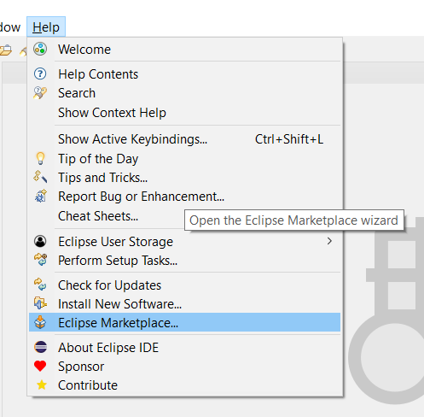
* 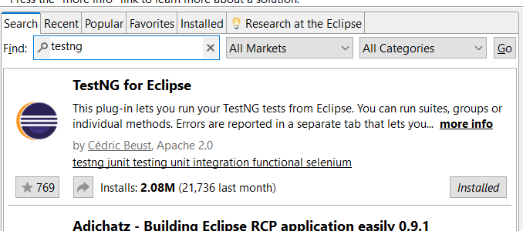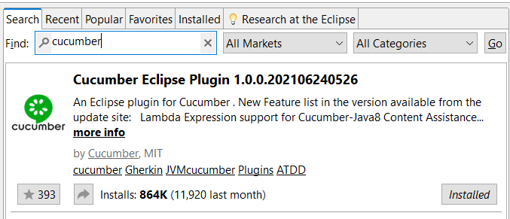
* Import the front-end automation testing project
  + Go to file -> import.. -> existing Maven projects
  + Select the front-end automation testing project
* Once importing project is successfully completed you will get a project structure
* 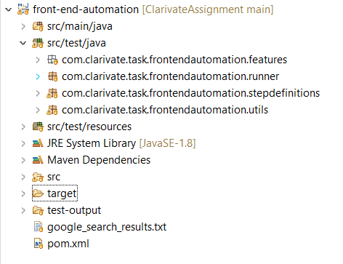
* Go to com.clarivate.task.frontendautomation.runner and open TestRunner.java file
* Right click on the opened file and run as testing
* Once test is executed successfully you will get the titles of googles search result will be in google_search_results.txt file
* Test result report will generate in target folder -> output.html

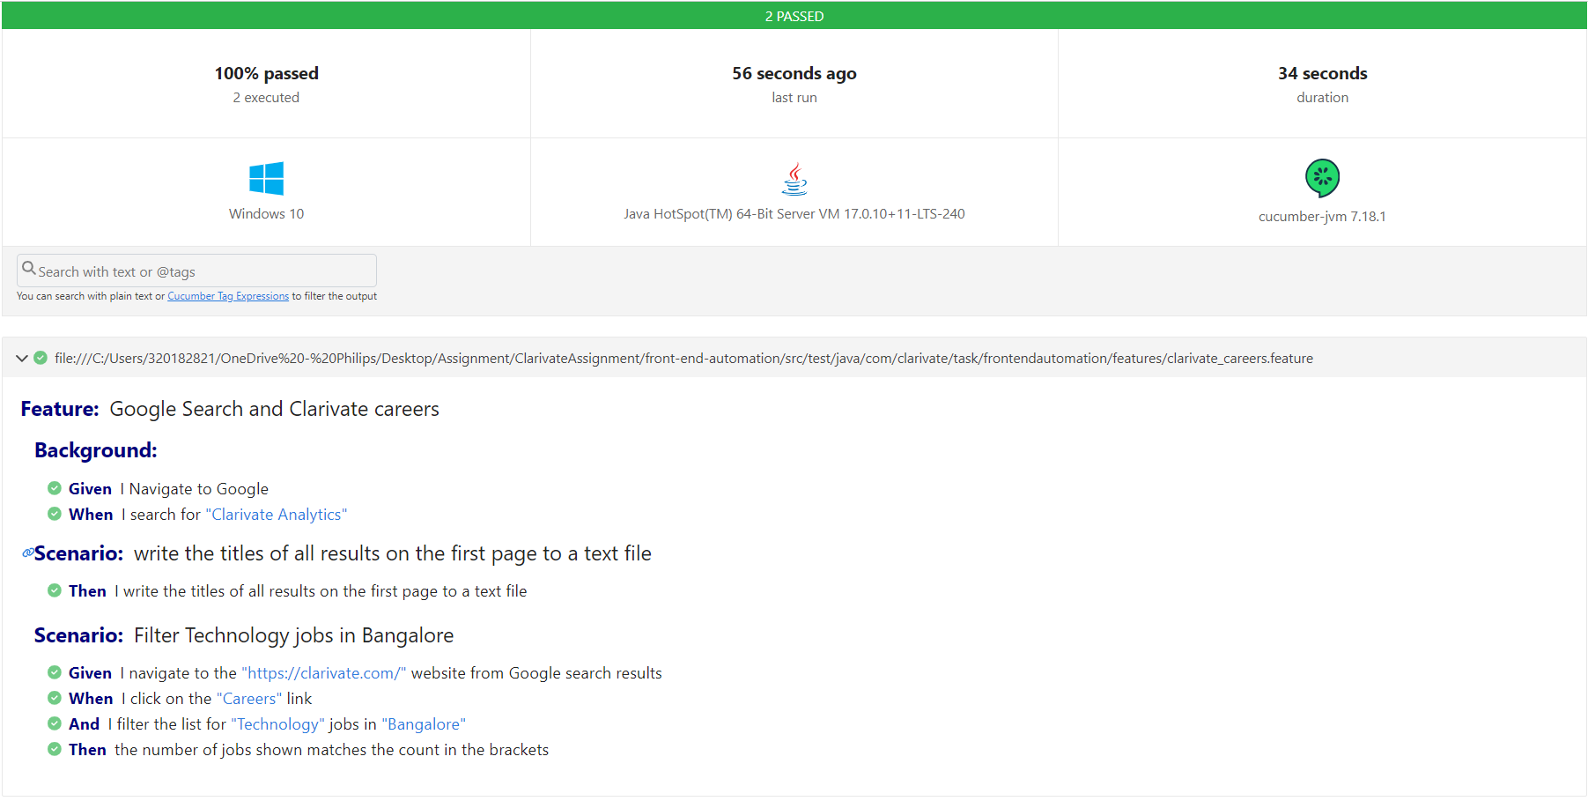

**Note:**

Due to My work load couldn’t include Maven setup, extent report, screenshots on failure test cases